SSN COLLEGE OF ENGINEERING, KALAVAKKAM
DEPARTMENT OF COMPUTER SCIENCE & ENGINEERING
Internet Programming Lab – CS8661
Programming Assignment 4 – Hello Servlet using Apache Tomcat Server ________________________________________________________________________

Write index.html to display form with a submit button. Set the method attribute of the form to “get” to generate GET request to the server. Write a java servlet to display welcome message when the button is clicked. Write also the configuration file, namely, web.xml which maps the url mapped to the servlet class file.

Follow the directory structure for creating HelloServlet Web application and follow the guidelines below to configure and deploy web application.

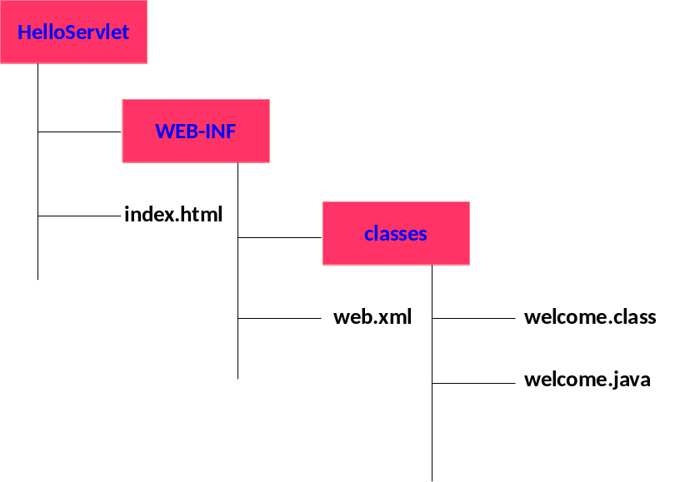

Assuming java is working on your laptop/desktop, To check, go to command prompt and type >javac
Download tomcat from tomcat official website Extract in to say C drive

How to install tomcat? (For Windows)
You need to create an environment variable called "JAVA_HOME" and set it to your JDK installed
directory.
1. First, take note of your JDK installed directory. The default is "c:\Program
Files\Java\jdk1.8.0_{xx}", where {xx} is the latest upgrade number. It is important to verify
your JDK installed directory, via the "Computer", before you proceed further.
2. Start a CMD shell, and issue the command "set JAVA_HOME" to check if variable JAVA_HOME
has been set:
3. > set JAVA_HOME
Environment variable JAVA_HOME not defined
If JAVA_HOME is set, check if it is set to your JDK installed directory correctly. Otherwise,
goto next step.
4. To set the environment variable JAVA_HOME in Windows 2000/XP/Vista/7/8: Push "Start"
button ⇒ Control Panel ⇒ System ⇒ (Vista/7/8) Advanced system settings ⇒ Switch to
"Advanced" tab ⇒ Environment Variables ⇒ System Variables ⇒ "New" (or "Edit" for
modification) ⇒ In "Variable Name", enter "JAVA_HOME" ⇒ In "Variable Value", enter your
JDK installed directory (e.g., " c:\Program Files\Java\jdk1.8.0_{xx}").
5. To verify, RE-START a CMD shell (need to refresh the environment) and issue:
6. > set JAVA_HOME
JAVA_HOME=c:\Program Files\Java\jdk1.8.0_{xx} <== Verify that this is YOUR JDK installed
directory
How to set class path?
1. Go to tomcat home directory and browse to …/lib/
2. Copy the path
3. Go to environment variables and under system variables create a new entry with
Variable name = CLASSPATH
Variable value = <the url you have just copied>
4. Save and exit.
How to install tomcat? (For Ubuntu)
- In Google, Type Apache Tomcat Installation Ubuntu 16.04 and find the liquid website
- Download tar file of Apache Tomcat 8.5.50 from Liquidweb site
- Extract and place it in /usr/local
- Check the version of java and its availability
- Usually we find in /usr/lib/jvm
- Need to set JAVA_HOME, PATH & CATALINA_HOME in bashrc file
- bashrc is a hidden file in home folder (~)
- Open the bashrc file using nano editor
- sudo nano ~/.bashrc
- Add the following
  - JAVA_HOME=“/usr/lib/jvm/java-1.8-openjdk-amd64”
  - PATH=$PATH:$JAVA_HOME
  - CATALINA_HOME=“/usr/local/apache-tomcat=8.5.50
- Update bashrc file using any one of the commands
  - source ~/.bashrc
  - . ~/.bashrc
- Check the environment variables by the following commands
  - $JAVA_HOME
  - $PATH
  - $CATALINA_HOME
- Start the server
  - $CATALINA_HOME/startup.sh
- Type the following in browser to check the administration page of Tomcat
  - http://localhost:8080
- Take demo Servlet from the following link
  - https://www.javatpoint.com/steps-to-create-a-servlet-using-tomcat-server
- Extract the folder, you will get demo servlet
- Place the demo servlet in webapps folder in apache-tomcat-8.5.50
- Type the following in browser to check demo servlet
  - http://localhost:8080/demo
- Shutdown the server
  - $CATALINA_HOME/bin/shutdown.sh
How to run the web application? (In windows)
1. Copy the HelloServlet application in webapps folder
2. Navigate to tomcat directory, go to bin
3. Execute startup.bat
4. Wait for the server to start
5. Open browser and navigate to the url : localhost:8080
6. A tomcat administartion page will be displayed.
7. To run firstservlet navigate to the url : http://localhost:8080/HelloServlet

How to run the web application? (In Ubuntu)
1. Copy the HelloServlet application in webapps folder
2. In terminal, type $CATALINA_HOME/bin/startup.sh3.
3. Wait for the server to start
4. Open browser and navigate to the url : localhost:8080
5. A tomcat administration page will be displayed.
6. To run firstservlet navigate to the url : http://localhost:8080/HelloServlet

